QUESTION 1
Code
?crabs
str(crabs)

crabs_table<-table(crabs$sex,crabs$sp)
crabs_table
barplot(crabs_table,col=2:3,main="Bar chart of Species and sex",
xlab="Species",ylab="sex")
Results
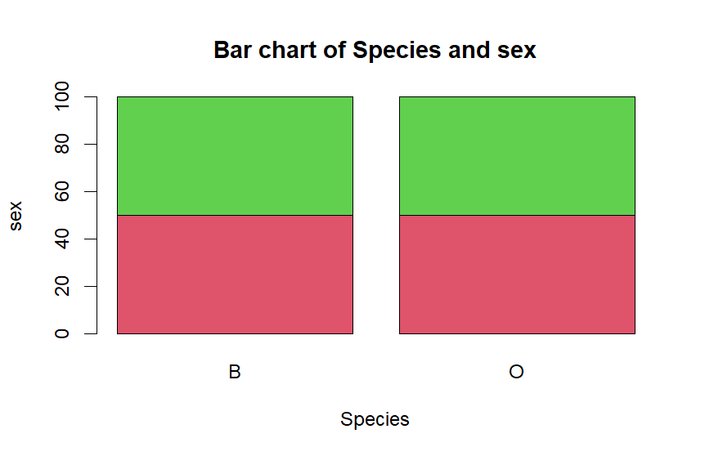

e) The dataset is balanced across the four groups with each gender count being equal among species.

QUESTION 2
Code
?interaction
boxplot(BD~interaction(crabs$sp,crabs$sex),
data = crabs,
col = (2:5),
main = "Body Depth (BD) by Species and Sex",
xlab = "Species and Sex",
ylab = "Body Depth (mm)",
names = c("Blue-Female", "Blue-Male",
"Orange-Female", "Orange-Male"))

Results
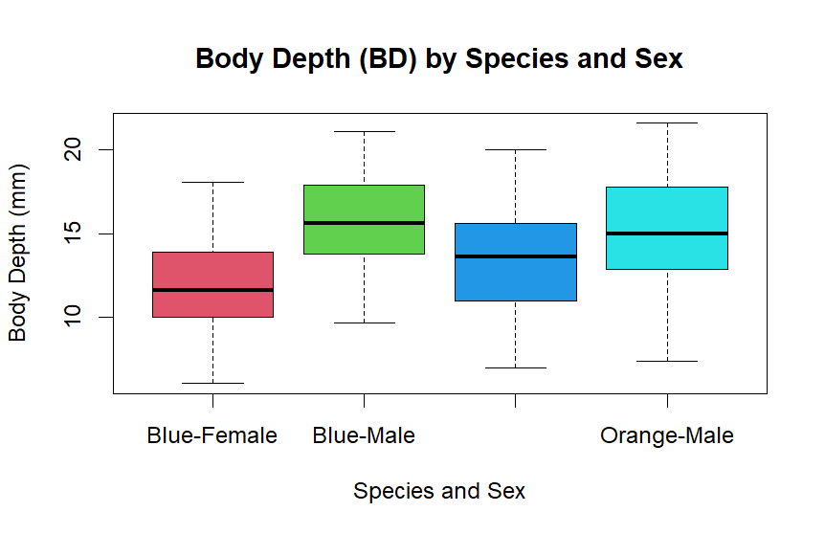

b) No extreme outliers were observed across groups. Also male crabs appear to have more body depth as against females.
QUESTION 3
Code
par(mfrow = c(1, 2))
hist(Crabs$CL[Crabs$sp == "B"],
main = "Carapace Length - Blue Species",
xlab = "Carapace Length (mm)",
ylab = "Frequency",
col = "lightblue",
border = "black")
hist(crabs$CL[crabs$sp == "O"],
main ="carapace Length - Orange",
xlab ="Carapace Length (mm)",
ylab ="Frequency",col="orange")

Results
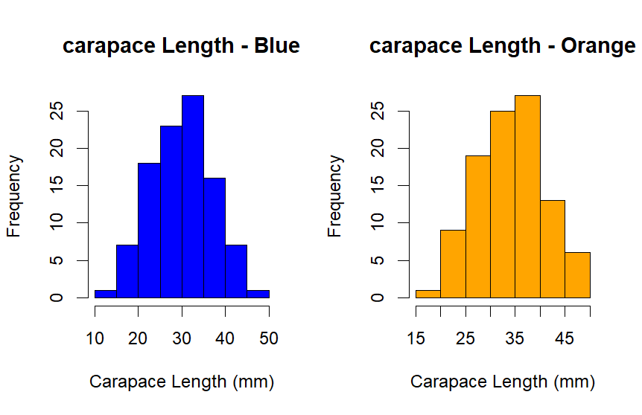
b) Both cases have one clear peak making both unimodal.
There is slight skewness (positive) in both cases.
QUESTION 4
Code
# Mean by species
tapply(crabs$FL,crabs$sp,mean)
tapply(crabs$RW,crabs$sp,mean)
tapply(crabs$CL,crabs$sp,mean)
tapply(crabs$CW,crabs$sp,mean)
tapply(crabs$BD,crabs$sp,mean)

# Mean by sex

tapply(crabs$FL,crabs$sex,mean)
tapply(crabs$RW,crabs$sp,mean)
tapply(crabs$CL,crabs$sp,mean)
tapply(crabs$CW,crabs$sp,mean)
tapply(crabs$BD,crabs$sp,mean)

means_by_species<-aggregate(cbind(FL, RW, CL, CW, BD)~sp,data = crabs,
FUN=mean)
means_by_species

species_mean_matrix<-as.matrix(means_by_species[ , -1])
rownames(species_mean_matrix)<-means_by_species$sp

means_by_sex<-aggregate(cbind(FL, RW, CL, CW, BD)~sex,data = crabs,
FUN=mean)
means_by_sex

sex_mean_matrix<-as.matrix(means_by_sex[ , -1])
rownames(sex_mean_matrix)<-means_by_sex$sp
par(mfrow = c(1, 2))
barplot(t(species_mean_matrix),
beside = TRUE,
col = c("blue", "orange"),
legend.text = rownames(species_mean_matrix),
args.legend = list(x = "topleft"),
main = "Mean Morphological
Measurements by Species",
xlab = "Morphology measurement",
ylab = "Mean Value (mm)")

barplot(t(species_mean_matrix),
beside = TRUE,
col = c("blue", "orange"),
legend.text = rownames(sex_mean_matrix),
args.legend = list(x = "topleft"),
main = "Mean Morphological
Measurements by Sex",
xlab = "Morphology measurement",
ylab = "Mean Value (mm)")
Results
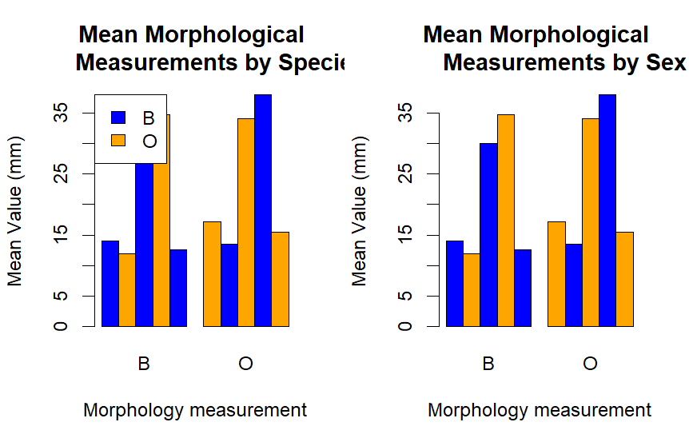

c) Greatest difference by species was seen in Carapace width(CW)
Frontal lobe(FL) is the least affected by sex

QUESTION 5
Code
morphology_measure<-crabs[,c("FL", "RW", "CL", "CW", "BD")]
morphology_measure
pairs(morphology_measure,col=2:6)

Results
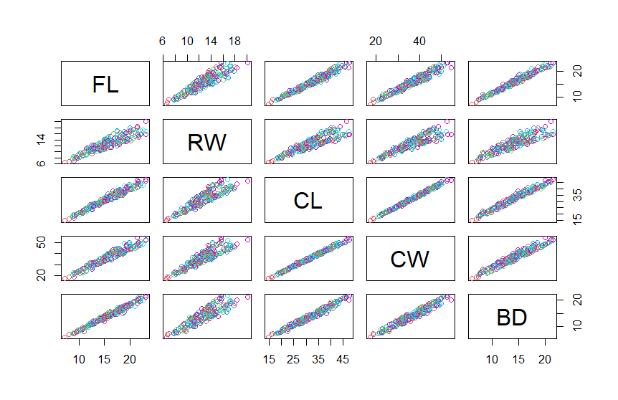

b) Variables appear to have positive correlations with each other. Increase in one variable corresponds with an increase in the paired variable.
CL VS CW have the strongest relationship.

QUESTION 6
The crabs data set consists of a five morphological measurements of crabs grouped into sex: Male and female and Species; Blue and Orange. The data set is perfectly balanced among the groups with each group having equal number of observations. This is evident in the figure below.
Fig.1


Distribution of body depth showed that male crabs have high body depths irrespective of species. With species, male of both species did not have much difference but female orange species appear to slightly more body depth than blue female species. The figure below depicts the above observation.
Fig.2

Caraspace length of both species behave the same way (positively skewed but approximately symmetric) but orange are generally larger than blue craps..

